Madagascar

## Population Data

The data set shows the political stability estimate of the country each year.

## # A tibble: 23 x 5  
## country iso3c date population popCategory5  
## <chr> <chr> <dbl> <dbl> <chr>   
## 1 Madagascar MDG 1996 13902688 small   
## 2 Madagascar MDG 1997 14347854 small   
## 3 Madagascar MDG 1998 14808791 small   
## 4 Madagascar MDG 1999 15282521 small   
## 5 Madagascar MDG 2000 15766806 small   
## 6 Madagascar MDG 2001 16260932 small   
## 7 Madagascar MDG 2002 16765117 small   
## 8 Madagascar MDG 2003 17279141 small   
## 9 Madagascar MDG 2004 17802997 small   
## 10 Madagascar MDG 2005 18336724 small   
## 11 Madagascar MDG 2006 18880269 small   
## 12 Madagascar MDG 2007 19433530 small   
## 13 Madagascar MDG 2008 19996473 small   
## 14 Madagascar MDG 2009 20569117 small   
## 15 Madagascar MDG 2010 21151640 small   
## 16 Madagascar MDG 2011 21743967 small   
## 17 Madagascar MDG 2012 22346641 small   
## 18 Madagascar MDG 2013 22961253 small   
## 19 Madagascar MDG 2014 23589887 small   
## 20 Madagascar MDG 2015 24234088 small   
## 21 Madagascar MDG 2016 24894380 small   
## 22 Madagascar MDG 2017 25570540 medium   
## 23 Madagascar MDG 2018 26262368 medium

# Population growth data

## # A tibble: 23 x 5  
## country iso3c date popGrowth popGrowthCat5   
## <chr> <chr> <dbl> <dbl> <chr>   
## 1 Madagascar MDG 1996 3.12 high growth rate  
## 2 Madagascar MDG 1997 3.15 high growth rate  
## 3 Madagascar MDG 1998 3.16 high growth rate  
## 4 Madagascar MDG 1999 3.15 high growth rate  
## 5 Madagascar MDG 2000 3.12 high growth rate  
## 6 Madagascar MDG 2001 3.09 high growth rate  
## 7 Madagascar MDG 2002 3.05 high growth rate  
## 8 Madagascar MDG 2003 3.02 high growth rate  
## 9 Madagascar MDG 2004 2.99 high growth rate  
## 10 Madagascar MDG 2005 2.95 high growth rate  
## 11 Madagascar MDG 2006 2.92 high growth rate  
## 12 Madagascar MDG 2007 2.89 high growth rate  
## 13 Madagascar MDG 2008 2.86 high growth rate  
## 14 Madagascar MDG 2009 2.82 high growth rate  
## 15 Madagascar MDG 2010 2.79 high growth rate  
## 16 Madagascar MDG 2011 2.76 high growth rate  
## 17 Madagascar MDG 2012 2.73 high growth rate  
## 18 Madagascar MDG 2013 2.71 high growth rate  
## 19 Madagascar MDG 2014 2.70 high growth rate  
## 20 Madagascar MDG 2015 2.69 high growth rate  
## 21 Madagascar MDG 2016 2.69 high growth rate  
## 22 Madagascar MDG 2017 2.68 high growth rate  
## 23 Madagascar MDG 2018 2.67 high growth rate

## Population trend

The plot shows the population trend of the country.

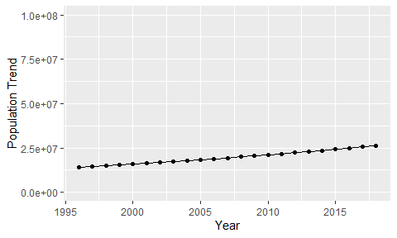

Political Stability Trend

# Population growth trend

The plot shows the population growth rate trend of the country.

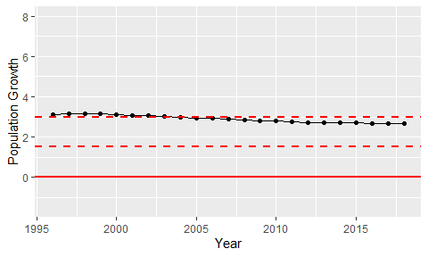

Population Growth Trend